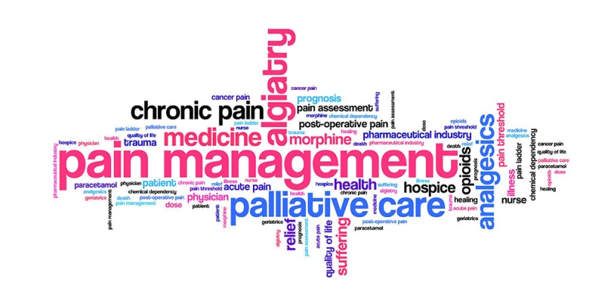
Foundation Core Teaching

Pain Management Seminars
*** Booking is essential via https://www.pgmeplymouth.com/pain-management as spaces are limited ***
Specifically designed seminars for Foundation Doctors as part of their core teaching hours. Although attendance at these sessions is not mandatory, they are of utmost importance and a patient safety issue. These sessions are useful, practical and highly relevant so we highly recommend you attend at least one of these seminars.
Monday lunchtimes 12:30-13:30 PGMC 2021-2022
August 22nd | Seminar Room 4
September 26th | Seminar Room 1
October 31st | Seminar Room 2
November 21st | Seminar Room 4
January 30th | Seminar Room 4
February 20th | Seminar Room 1
March 20th | Seminar Room 4
April 17th | Seminar Room 4

Confused about managing complex pain problems?

Not sure what chronic pain is?

Difficulty managing opioid-tolerant patients?

What is neuropathic pain?

What should I prescribe at discharge?

If you know the answers to all these questions, don’t come. If not, drop in and learn. Bring lunch. Taught by Dr M Rockett inpatient pain management lead.
“Acute pain management and safe opioid use is of utmost importance and a patient safety issue”
(F2 Programme Director)

“Easily the most relevant teaching we have had” ”Well presented, pitched at right level” “Nice to have some proper medical teaching in pharmacology” “ Really useful, not too much information all at once, a good amount for remembering”
(F2 Feedback)

PLEASE NOTE: Covid-19 - The speaker (Dr Rockett) will be delivering these sessions face to face; however, this could change last minute due to Dr Rockett having so self-isolate etc. Therefore, please keep an eye on emails/WhatsApp/website for any last-minute changes. However, we MUST request that you book onto a session via the website so that we can monitor numbers, and please attend face to face unless told differently. If for any reason, you cannot attend any of these sessions in person please contact the foundation team.

